## Тестування API. JSON. REST.

## Beet Sprout — детальніше заглибся в практику.

1. В Google docs створи 5 тест-кейсів для функціонального тестування сайту https://automoto.ua/uk/ (5 найбільш пріоритетних тестів). Посилання на документ додай до ЛМС.

<https://docs.google.com/spreadsheets/d/1UgrQJMsUBwIN3QhOB9j7dH8cCMs20b6l/edit#gid=533480428>

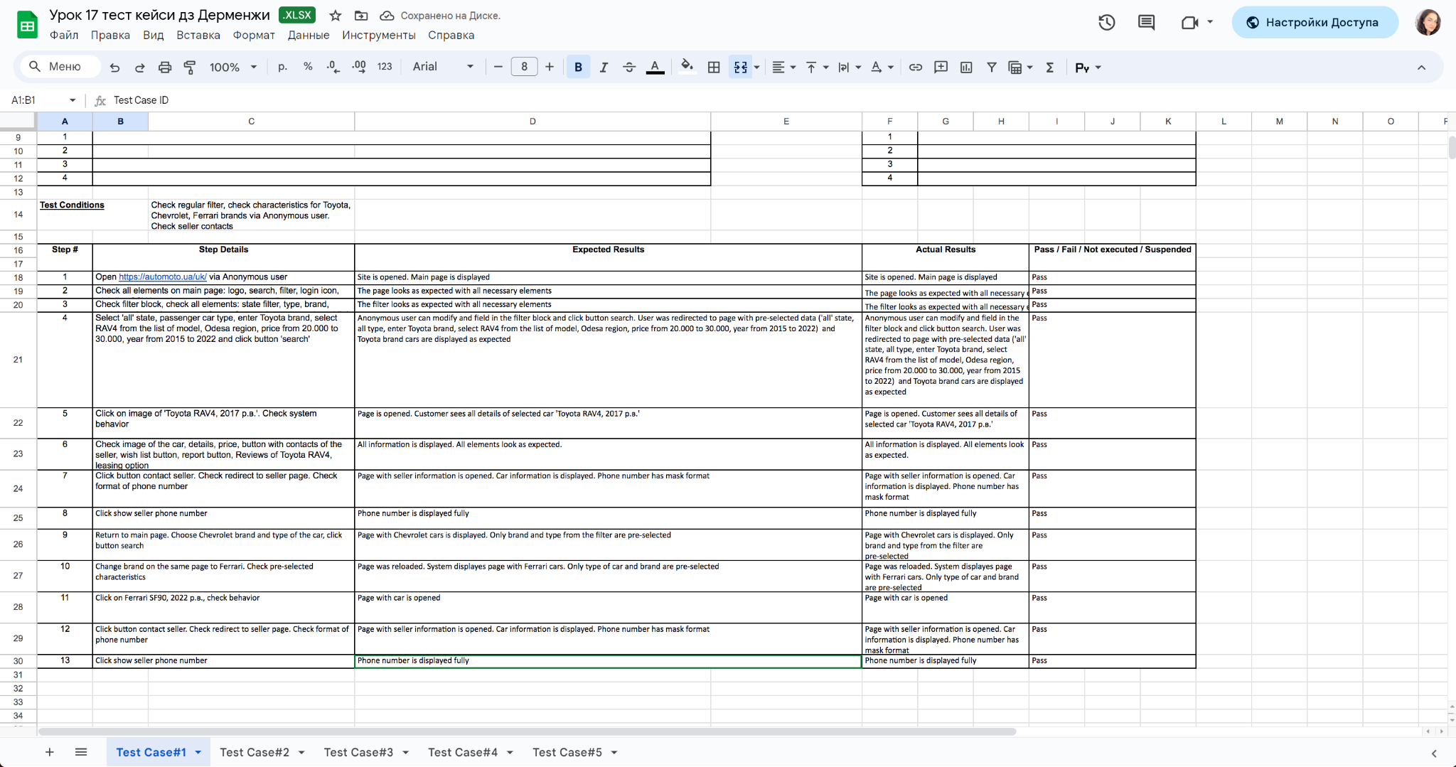

2. За допомогою https://reqbin.com/ протестуй наступні методи API Reqres:

LIST USERS

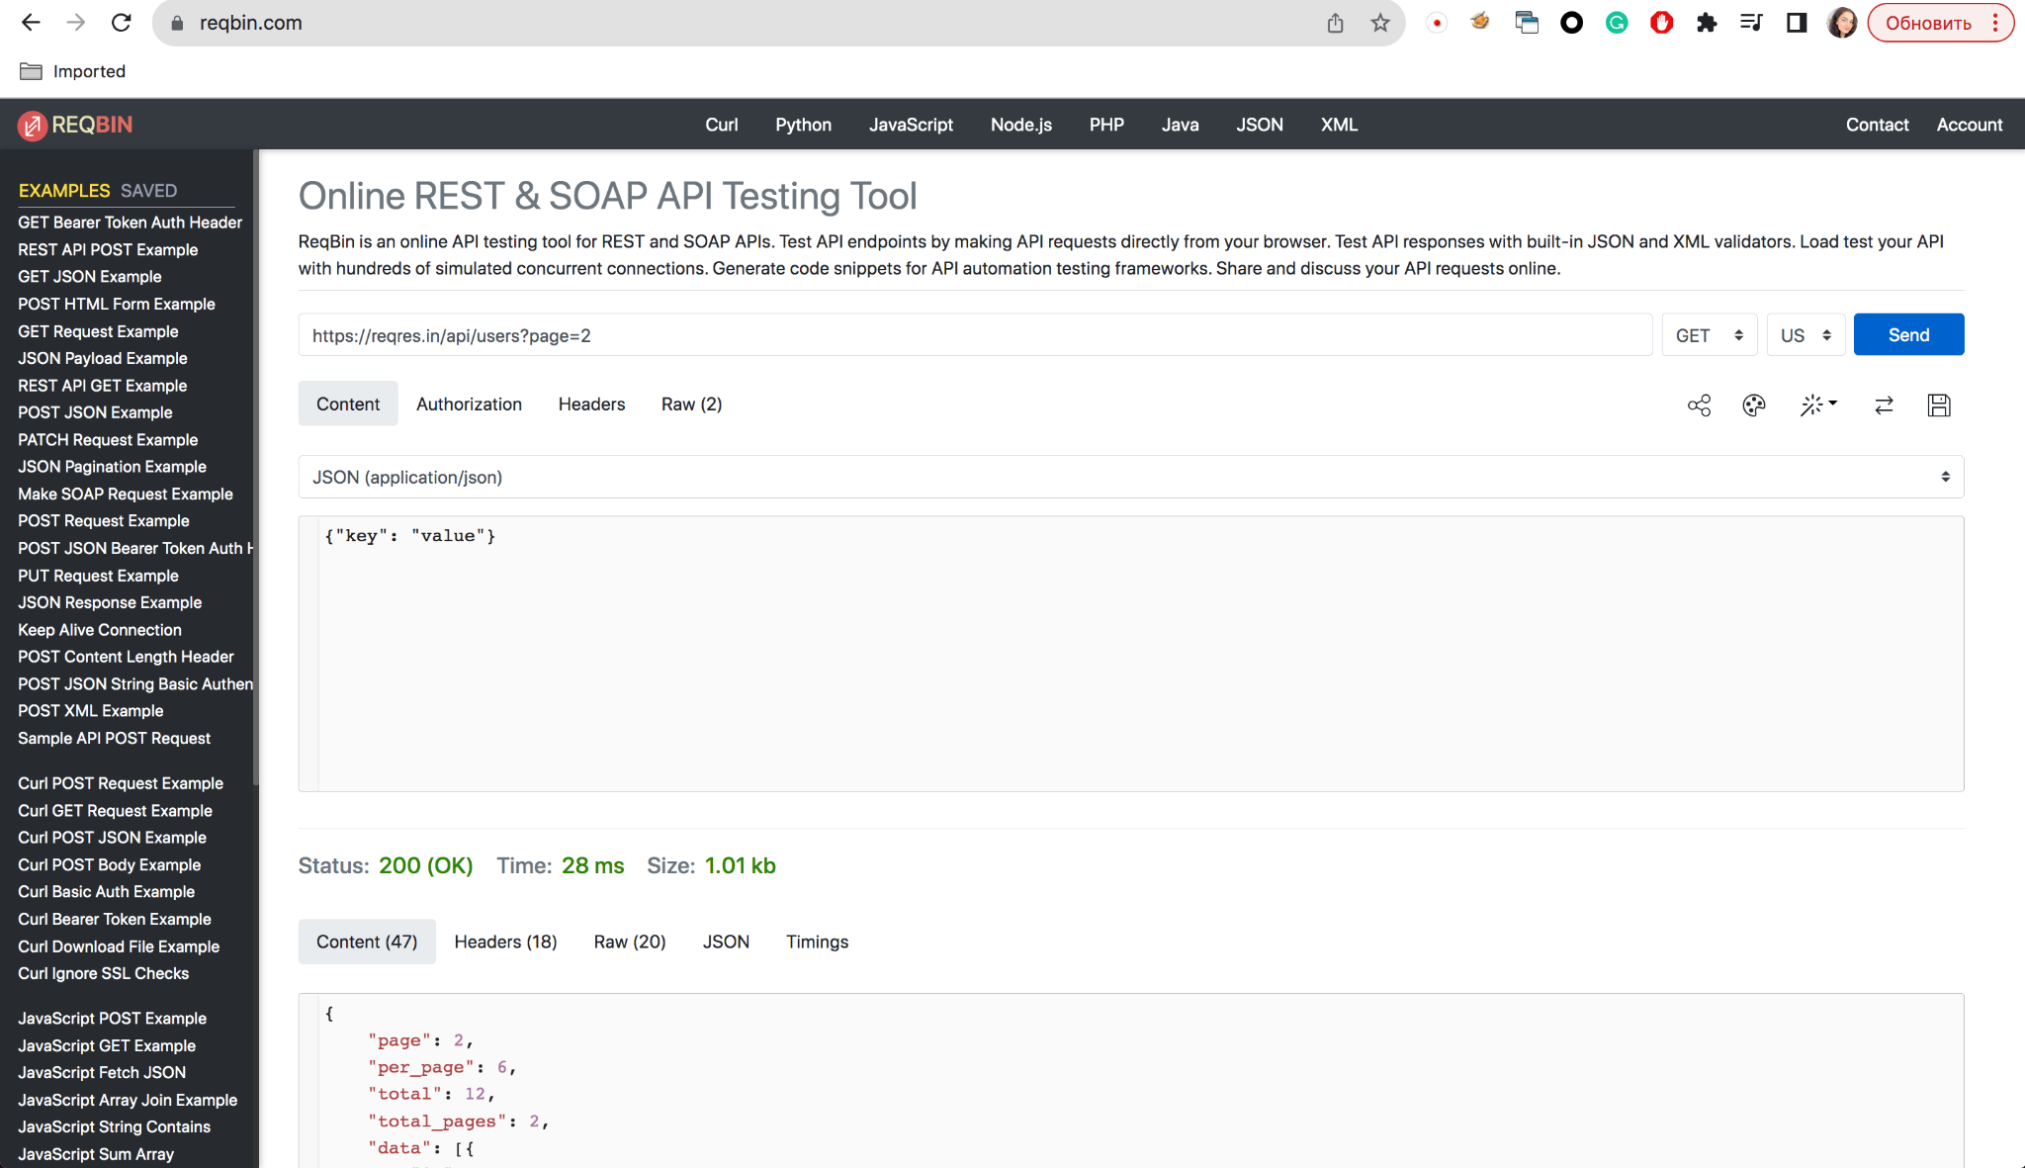

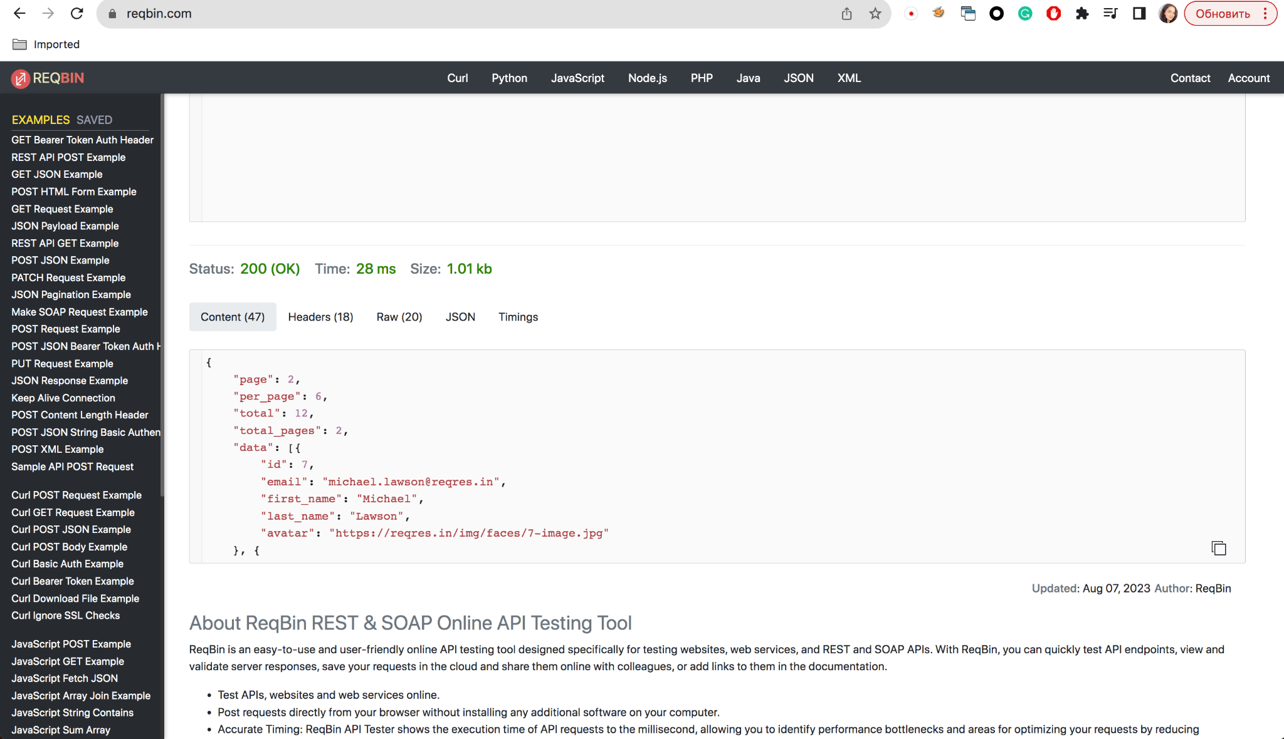

{

"page": 2,

"per_page": 6,

"total": 12,

"total_pages": 2,

"data": [{

"id": 7,

"email": "michael.lawson@reqres.in",

"first_name": "Michael",

"last_name": "Lawson",

"avatar": "https://reqres.in/img/faces/7-image.jpg"

}, {

"id": 8,

"email": "lindsay.ferguson@reqres.in",

"first_name": "Lindsay",

"last_name": "Ferguson",

"avatar": "https://reqres.in/img/faces/8-image.jpg"

}, {

"id": 9,

"email": "tobias.funke@reqres.in",

"first_name": "Tobias",

"last_name": "Funke",

"avatar": "https://reqres.in/img/faces/9-image.jpg"

}, {

"id": 10,

"email": "byron.fields@reqres.in",

"first_name": "Byron",

"last_name": "Fields",

"avatar": "https://reqres.in/img/faces/10-image.jpg"

}, {

"id": 11,

"email": "george.edwards@reqres.in",

"first_name": "George",

"last_name": "Edwards",

"avatar": "https://reqres.in/img/faces/11-image.jpg"

}, {

"id": 12,

"email": "rachel.howell@reqres.in",

"first_name": "Rachel",

"last_name": "Howell",

"avatar": "https://reqres.in/img/faces/12-image.jpg"

}],

"support": {

"url": "https://reqres.in/#support-heading",

"text": "To keep ReqRes free, contributions towards server costs are appreciated!"

}

}

SINGLE USER

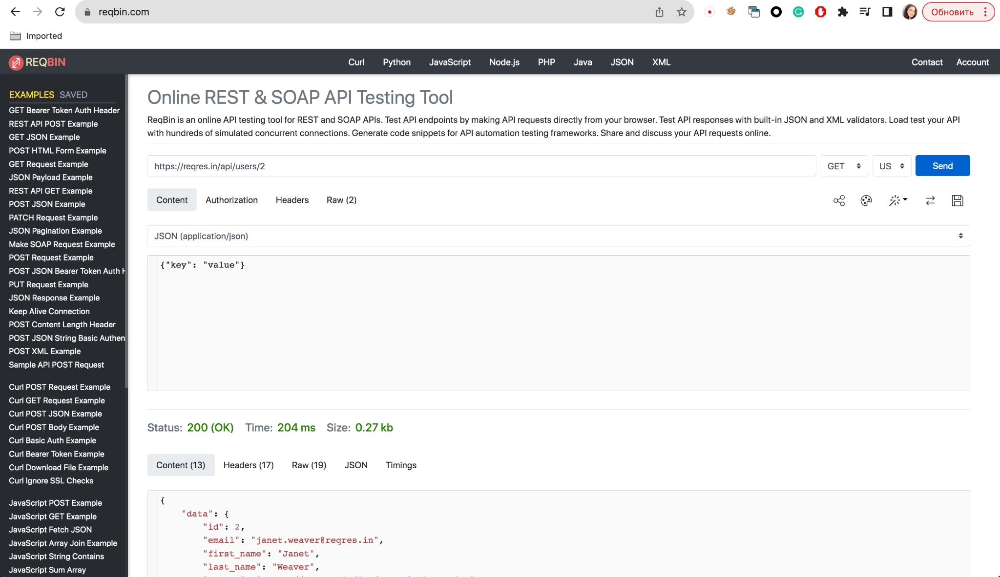

{

"data": {

"id": 2,

"email": "janet.weaver@reqres.in",

"first_name": "Janet",

"last_name": "Weaver",

"avatar": "https://reqres.in/img/faces/2-image.jpg"

},

"support": {

"url": "https://reqres.in/#support-heading",

"text": "To keep ReqRes free, contributions towards server costs are appreciated!"

}

}

CREATE

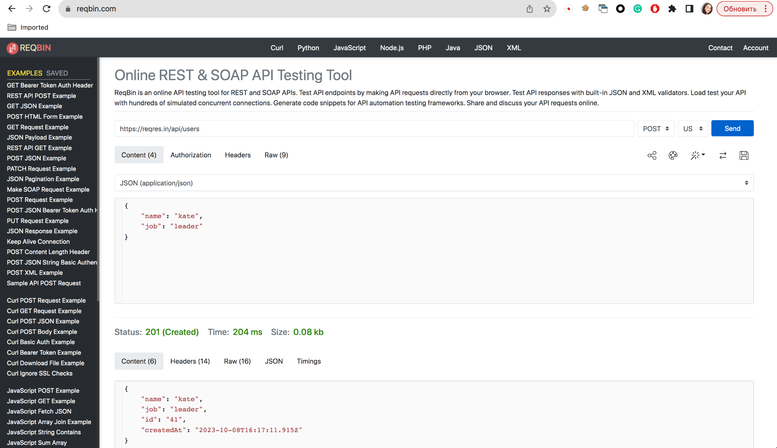

{

"name": "kate",

"job": "leader",

"id": "41",

"createdAt": "2023-10-08T16:17:11.915Z"

}

UPDATE (PUT)

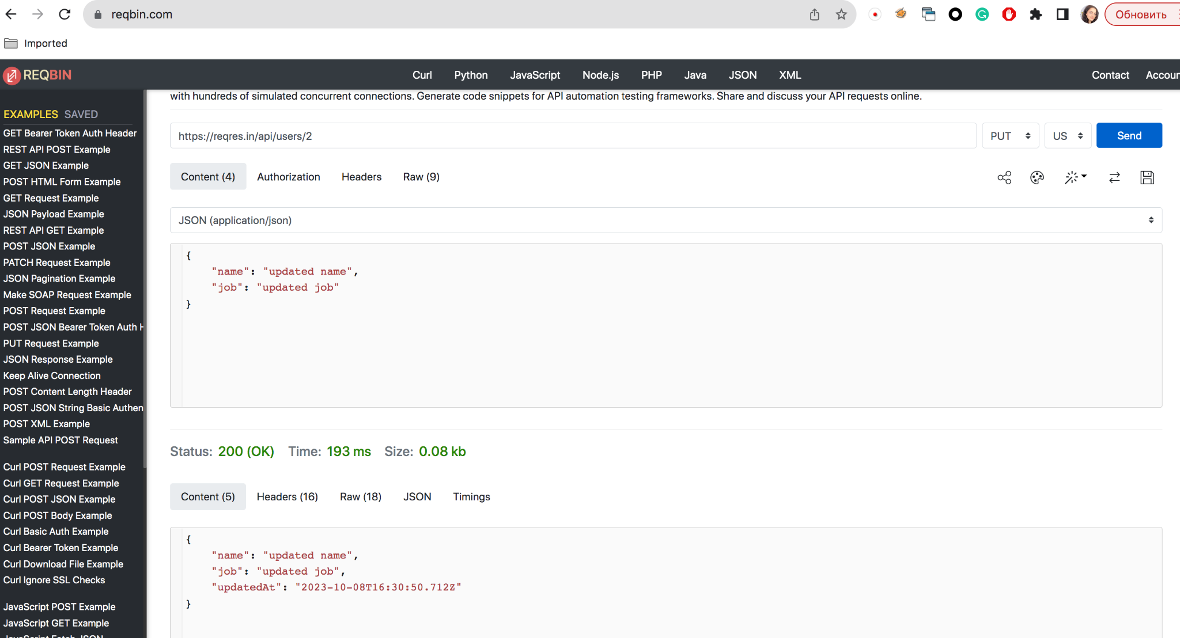

{

"name": "updated name",

"job": "updated job",

"updatedAt": "2023-10-08T16:30:50.712Z"

}

UPDATE (PATCH)

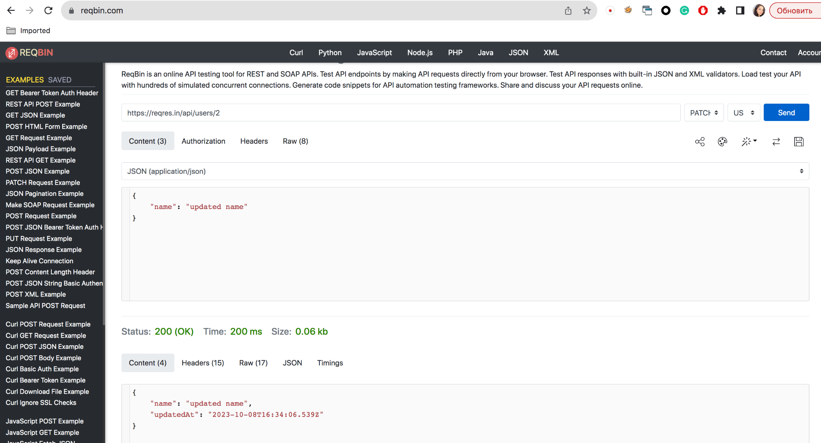

{

"name": "updated name",

"updatedAt": "2023-10-08T16:34:06.539Z"

}

DELETE

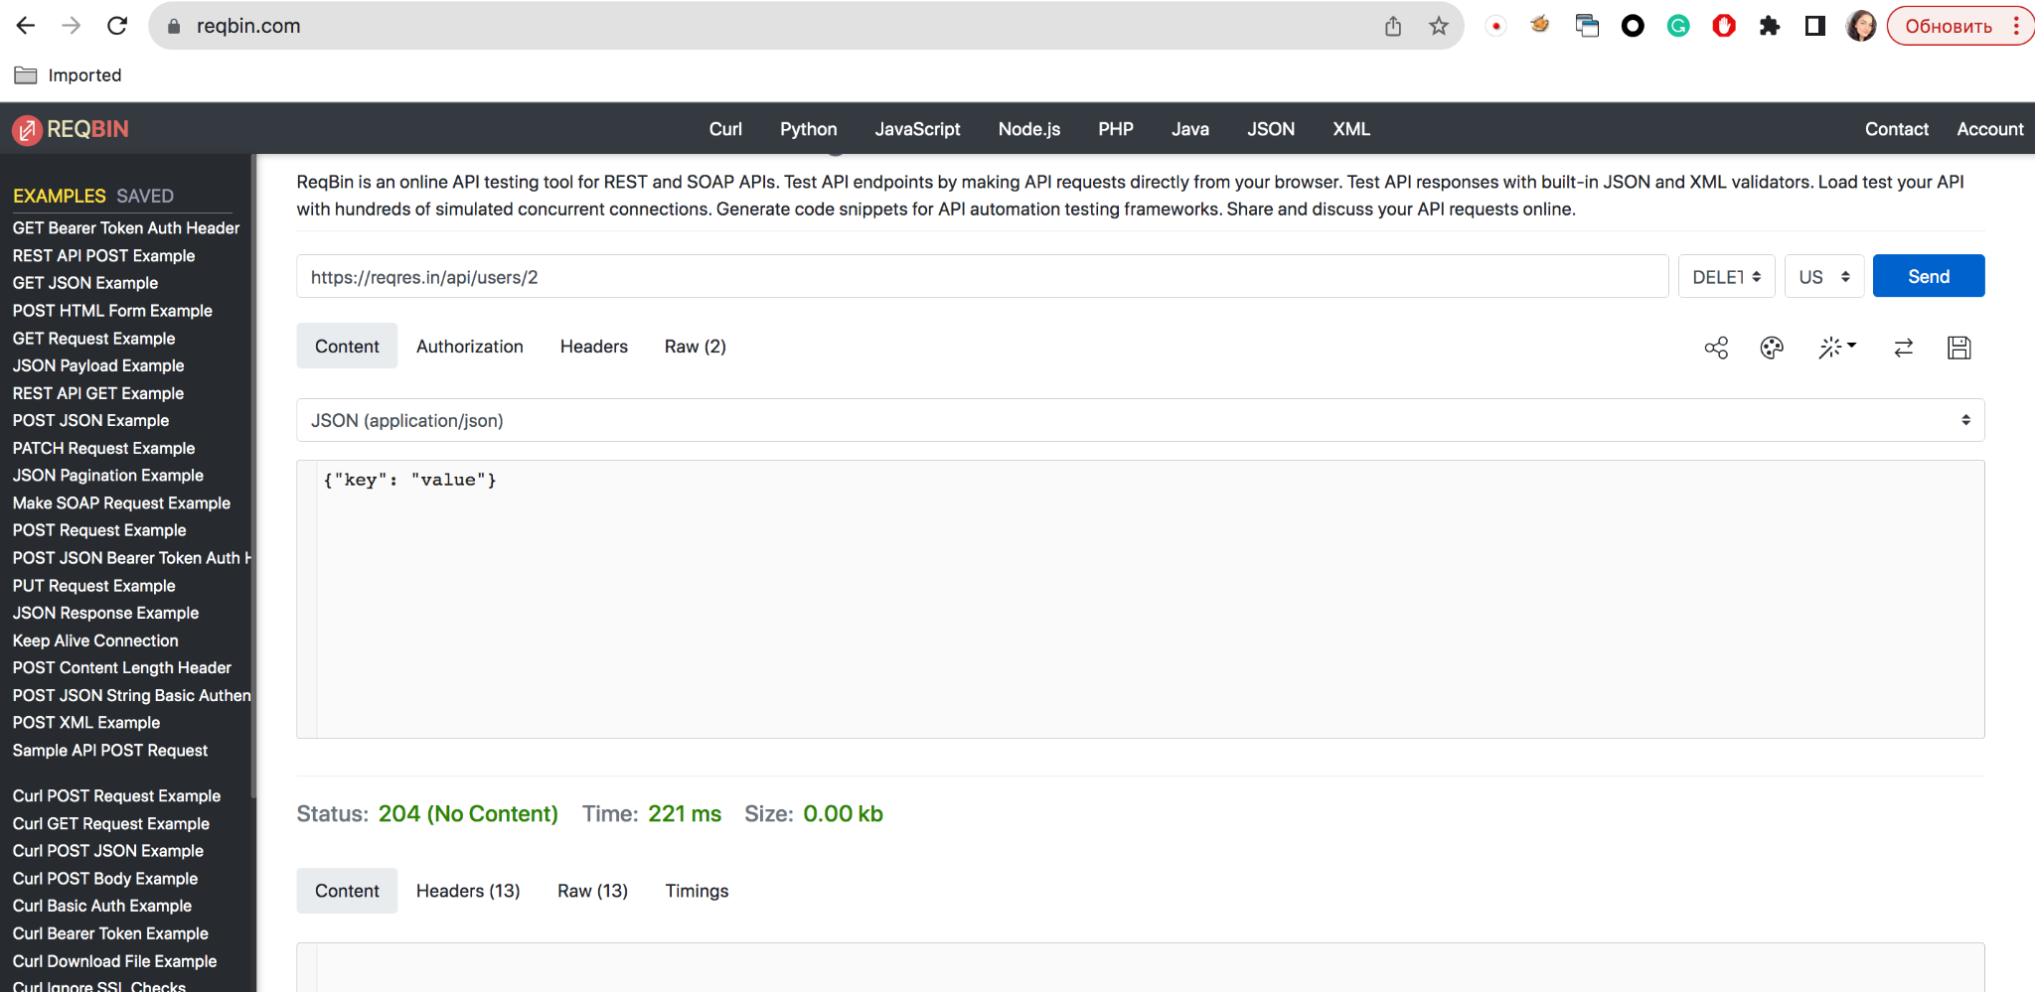

REGISTER - SUCCESSFUL

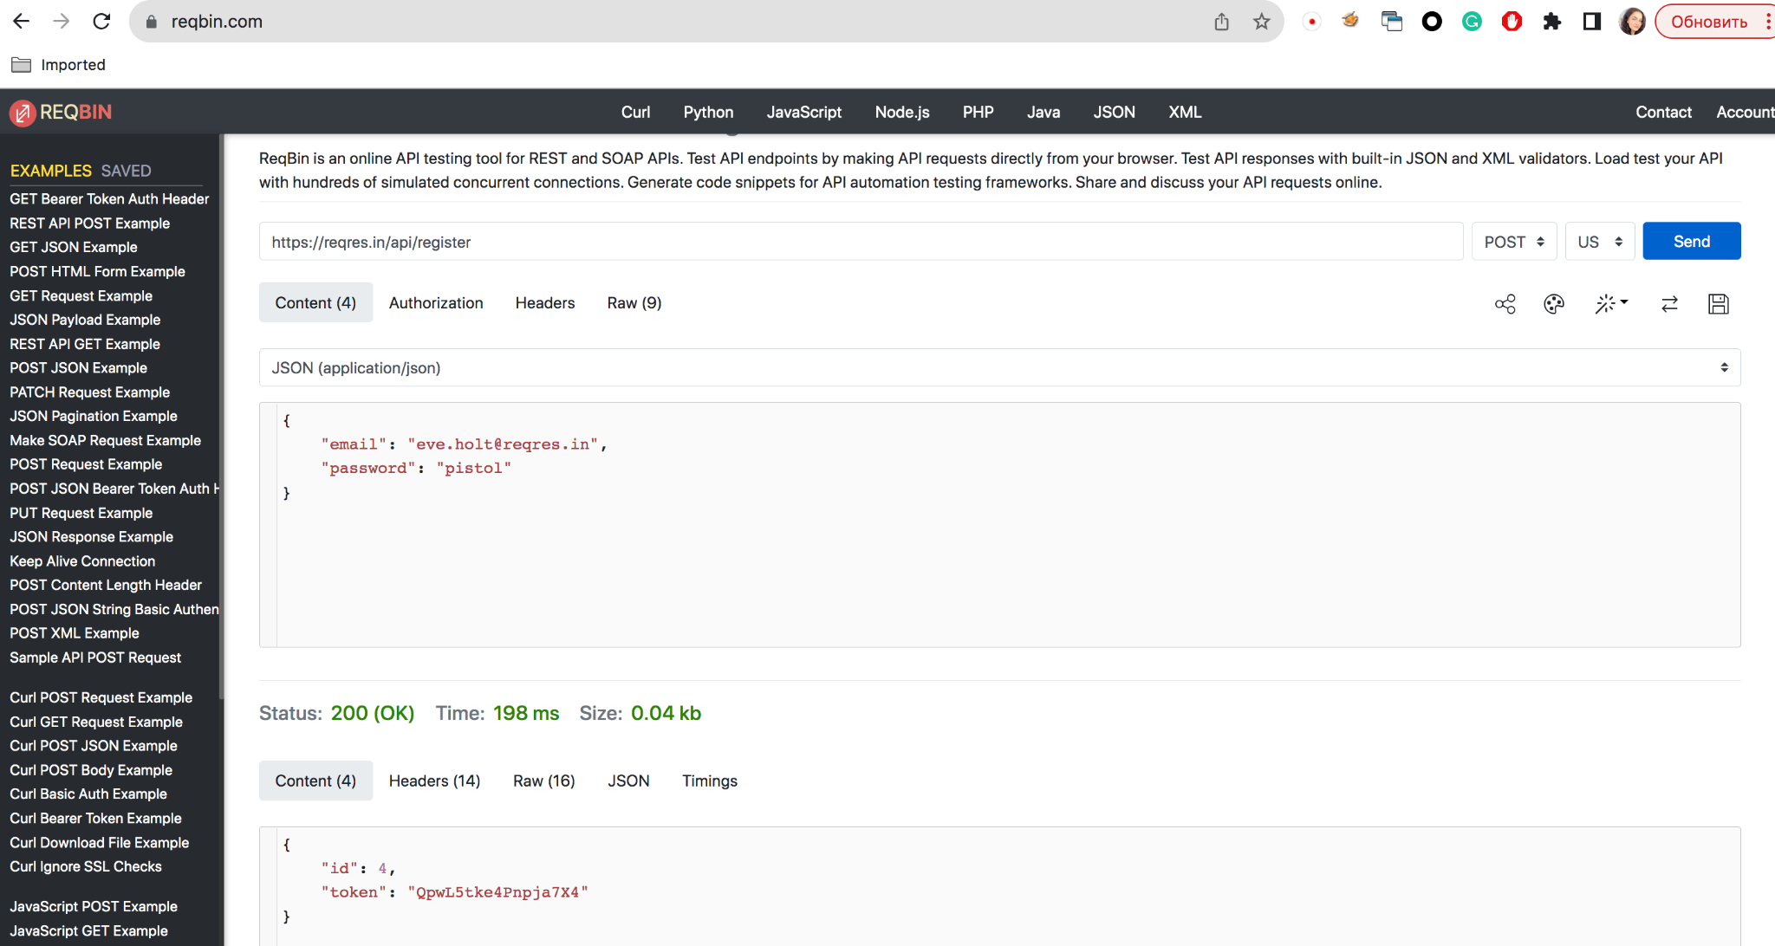

LOGIN - SUCCESSFUL

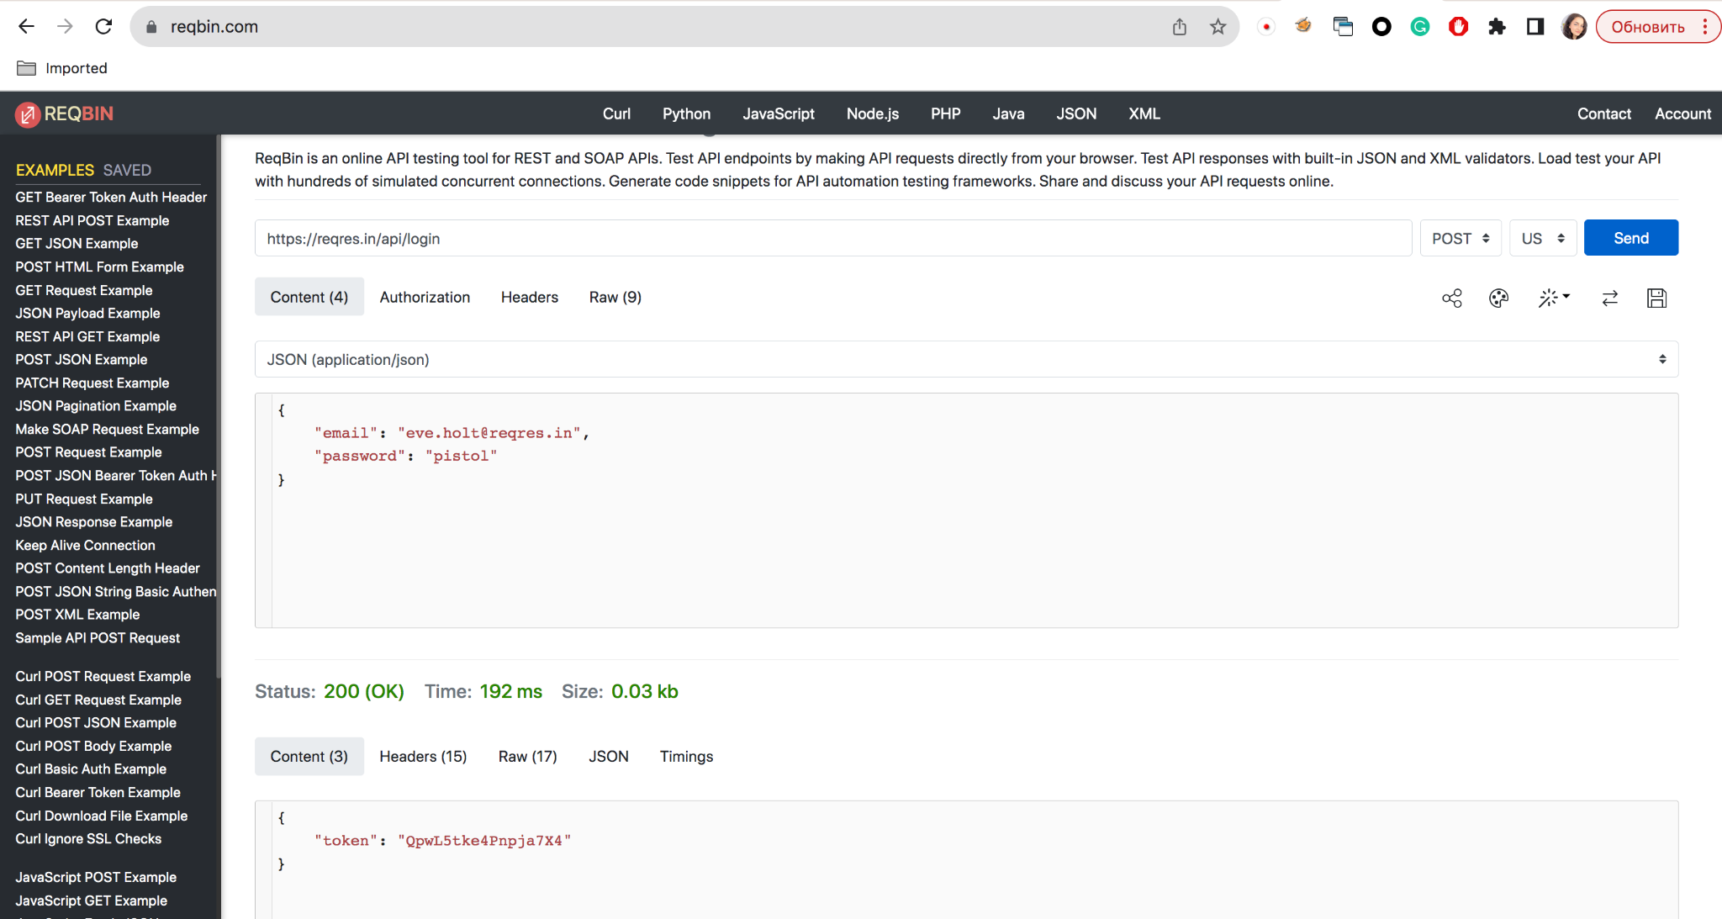

Створи документ, в якому у довільному форматі, але зі скриншотами, опиши знайдені баги. Документ додай до LMS.

**Bug Report#1**

Summary: User was created with empty request body

Description

Steps:

1. Send POST request with empty body:

curl -X POST https://reqres.in/api/users -H "Content-Type: application/json" -H "Content-Length: 0"

1. Check HTTP response

AR: Customer was created without “name” and “job” fields

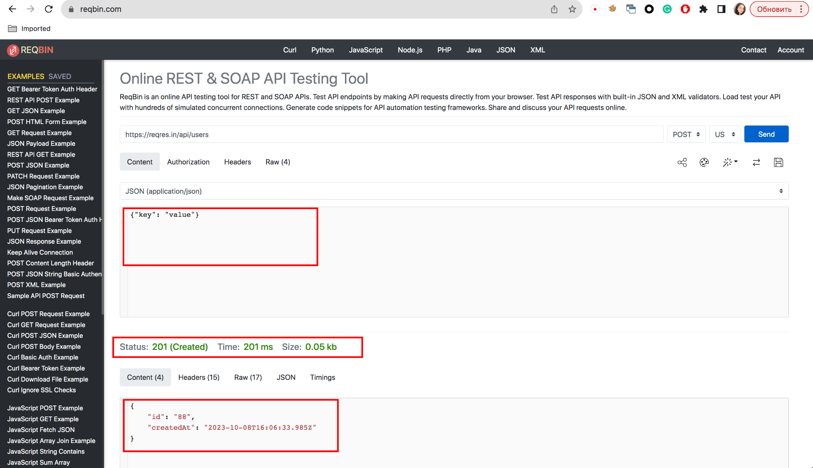

ER: Customer was not created without mandatory fields

**Bug Report #2**

Summary: User can be created with custom field

Description

Step:

1. Send POST request:  
   curl -X POST https://reqres.in/api/users -H "Accept: application/json"" -H "Content-Type: application/json" --data-binary @- <<DATA

{

"name": "kate",

"job": "leader",

"myfield" : 5

}

DATA

1. Check response

AR: Customer is created with custom fields

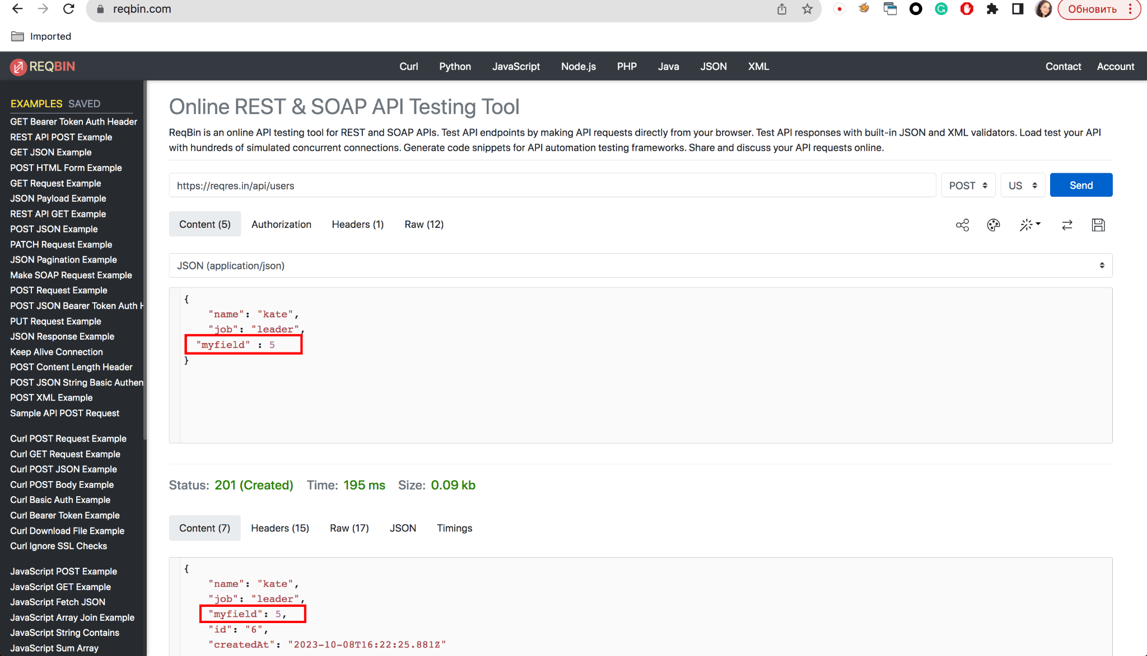

ER: Customer is created with defined fields only: name, id, job, createdAt